Directions: Solve the following inequalities.
$|2x|<6$ $|x+5|>2$ $|2x−2|≤8$

Two-Way Inequality: Two-Way Inequality: Two-Way Inequality:

Interval Interval Interval
Notation: __________ Notation: __________ Notation: __________

Directions: Sketch the graphs of the following inequalities.

$y>−\frac{1}{2}x+4$ $6x−2y>\text{10}$

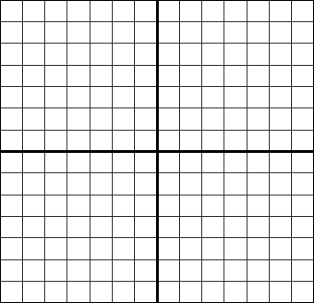

Directions: Solve the following systems of linear inequalities by graphing.

